**Essential Cheat Sheets for Machine Learning and Deep Learning Engineers**

Learning machine learning and deep learning is difficult for newbies. As well as deep learning libraries are difficult to understand. I am creating a repository on Github([cheatsheets-ai](https://github.com/kailashahirwar/cheatsheets-ai" \t "_blank)) with cheat sheets which I collected from different sources. Do visit it and contribute cheat sheets if you have any. Thanks.

1. Keras

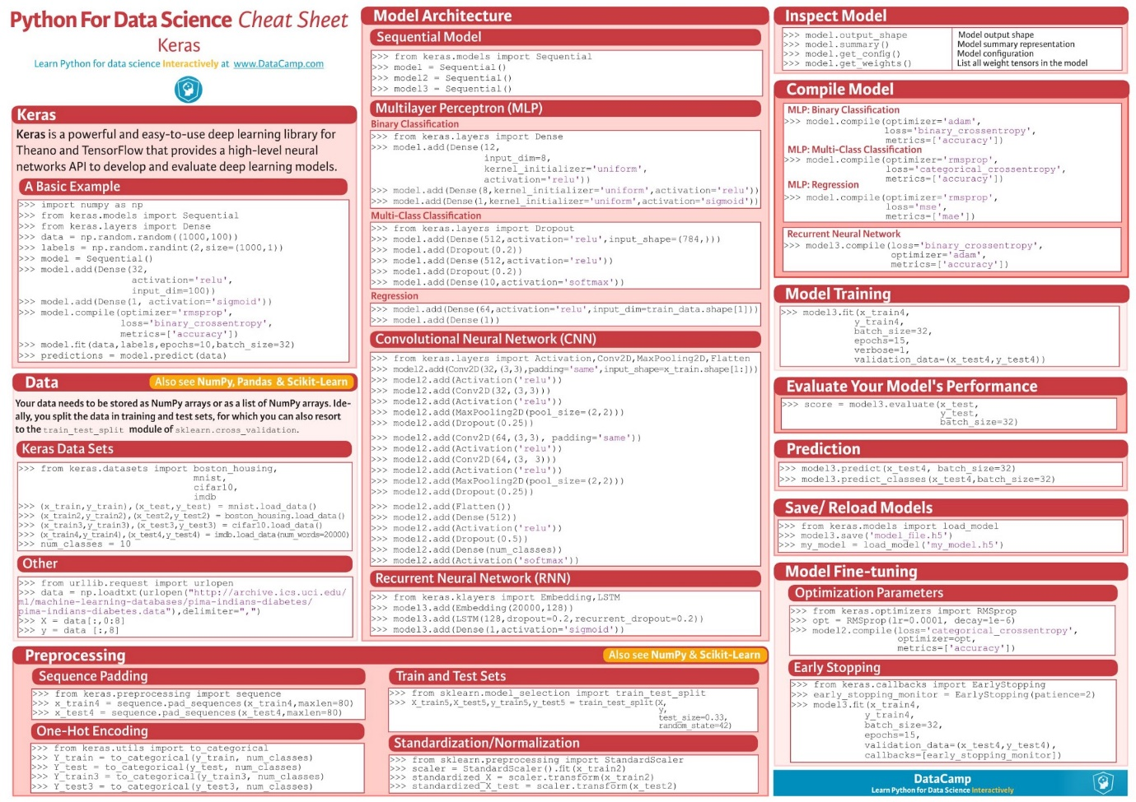

Source — <https://www.datacamp.com/community/blog/keras-cheat-sheet#gs.DRKeNMs>

2. Numpy

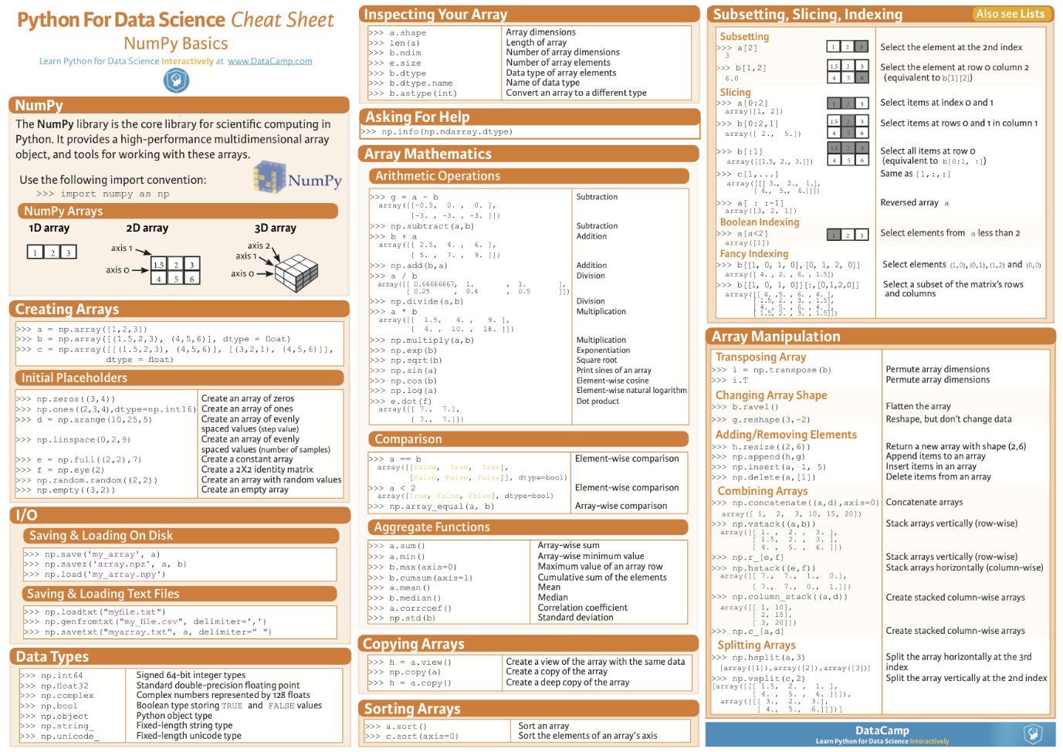

Source — <https://www.datacamp.com/community/blog/python-numpy-cheat-sheet#gs.AK5ZBgE>

3. Pandas

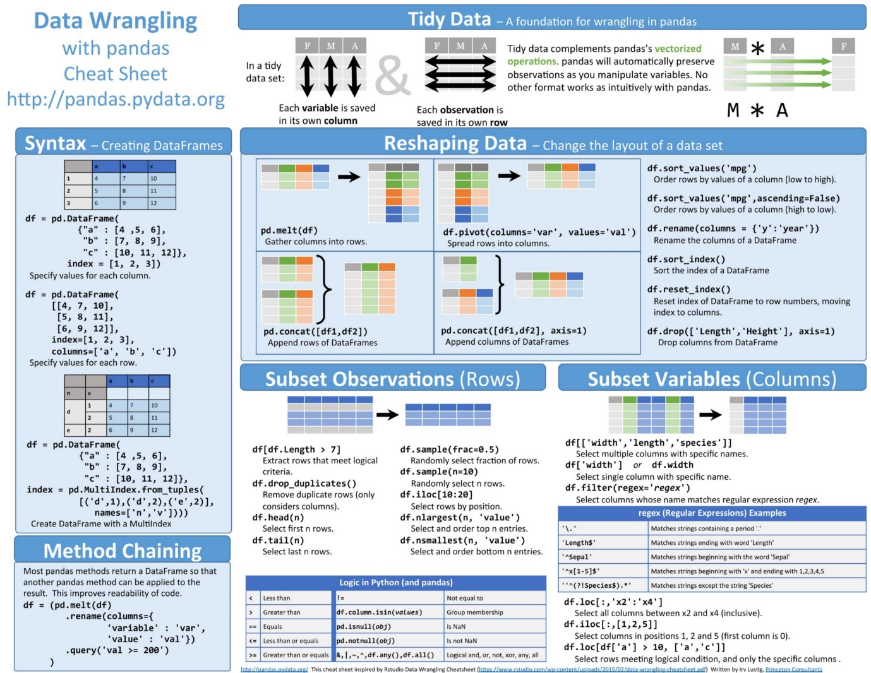

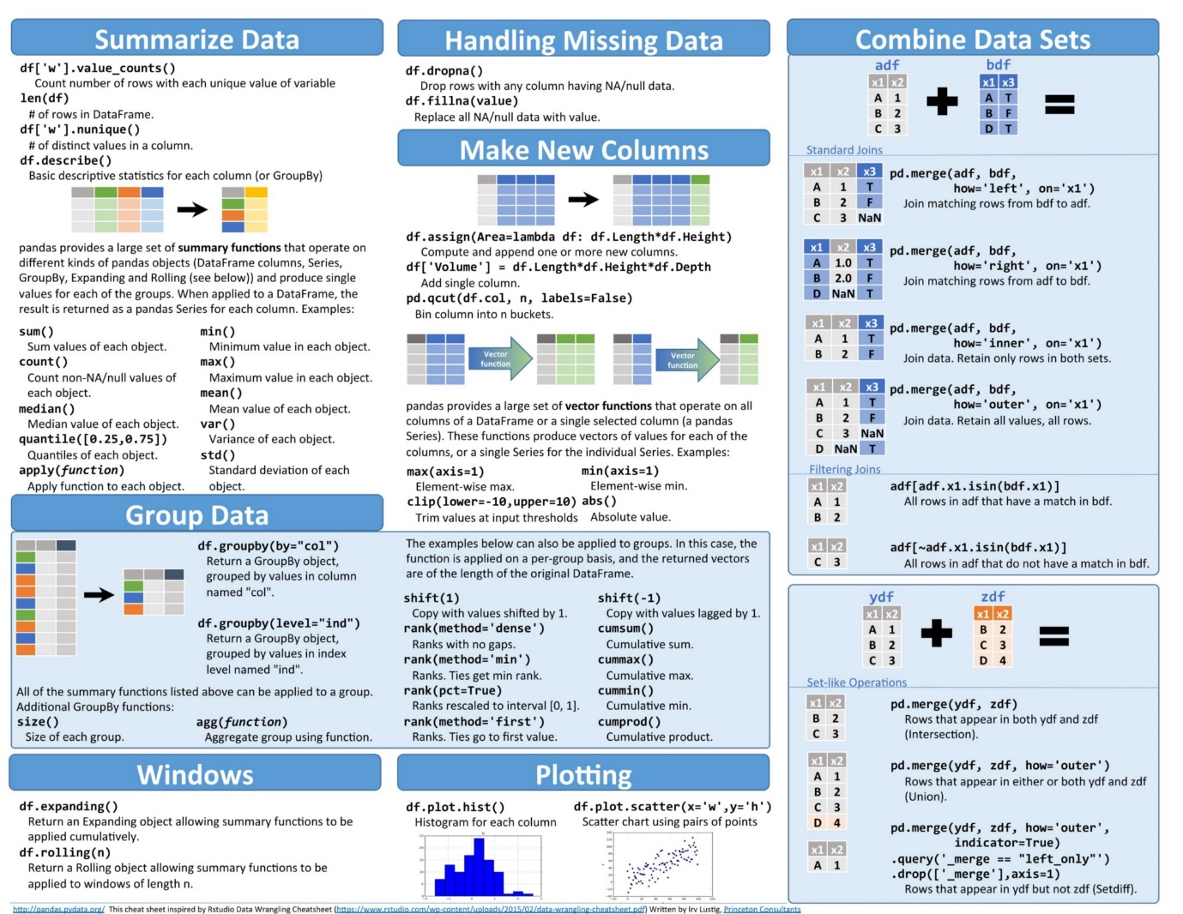

Source — <https://www.datacamp.com/community/blog/pandas-cheat-sheet-python#gs.HPFoRIc>

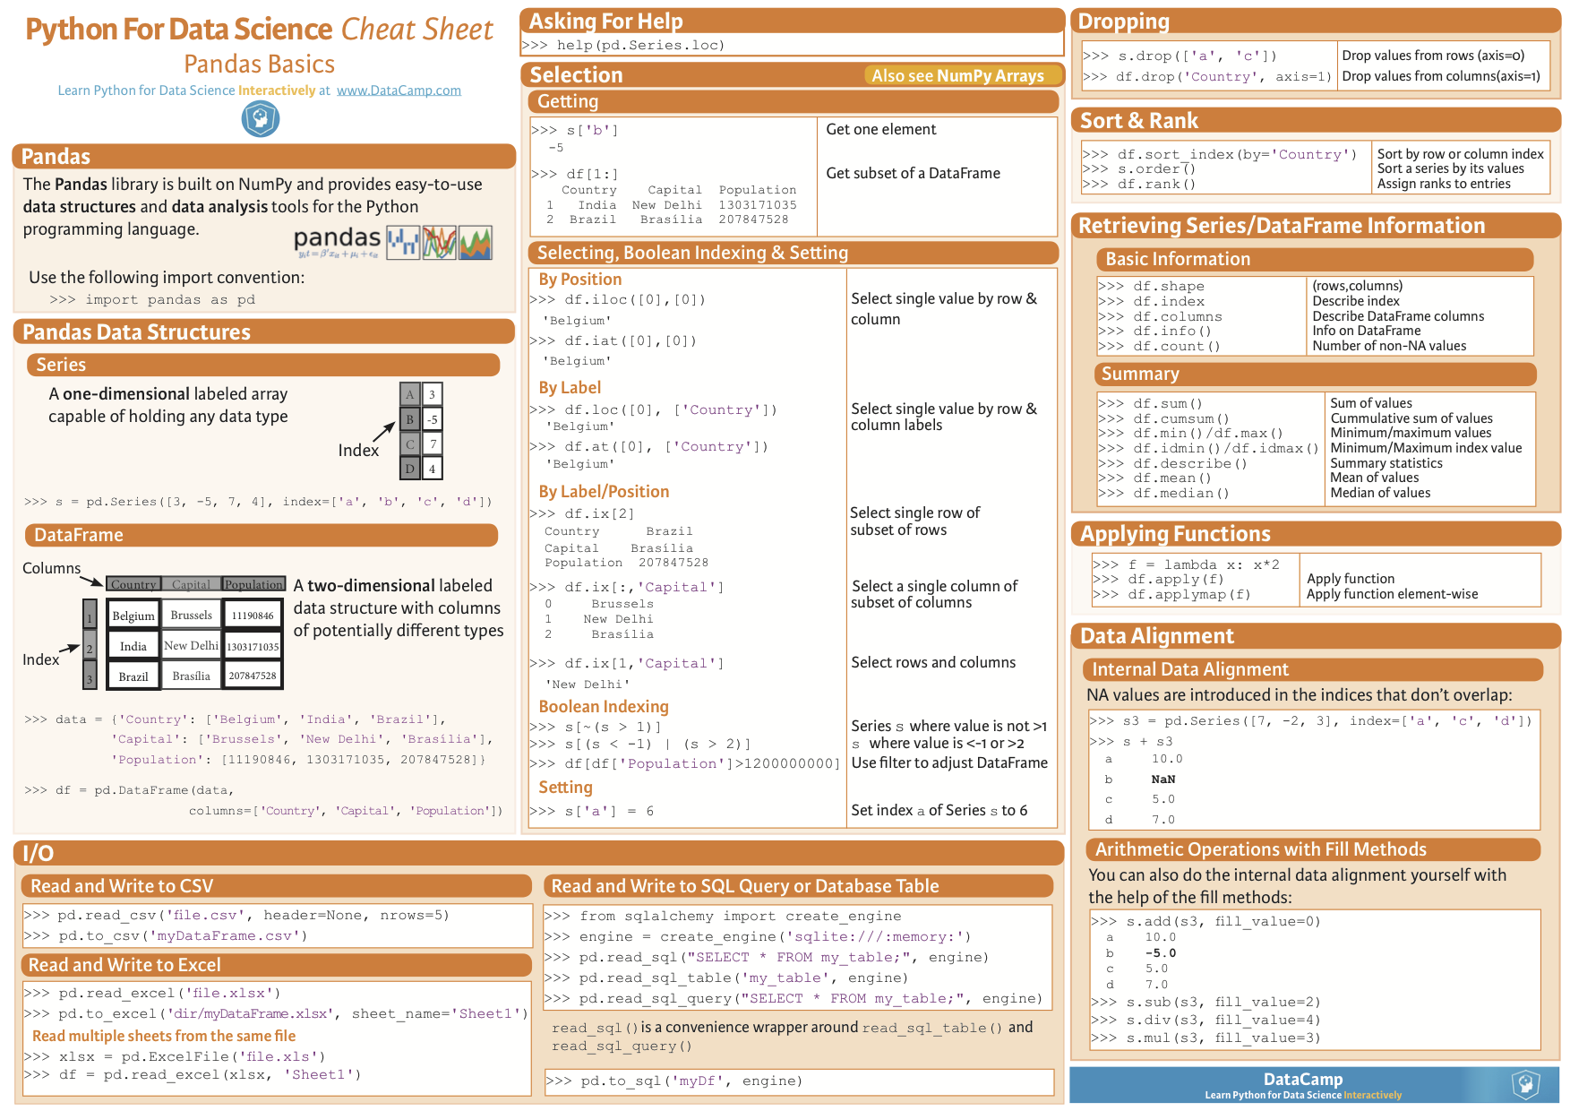

Source — <https://www.datacamp.com/community/blog/python-pandas-cheat-sheet#gs.oundfxM>

4. Scipy

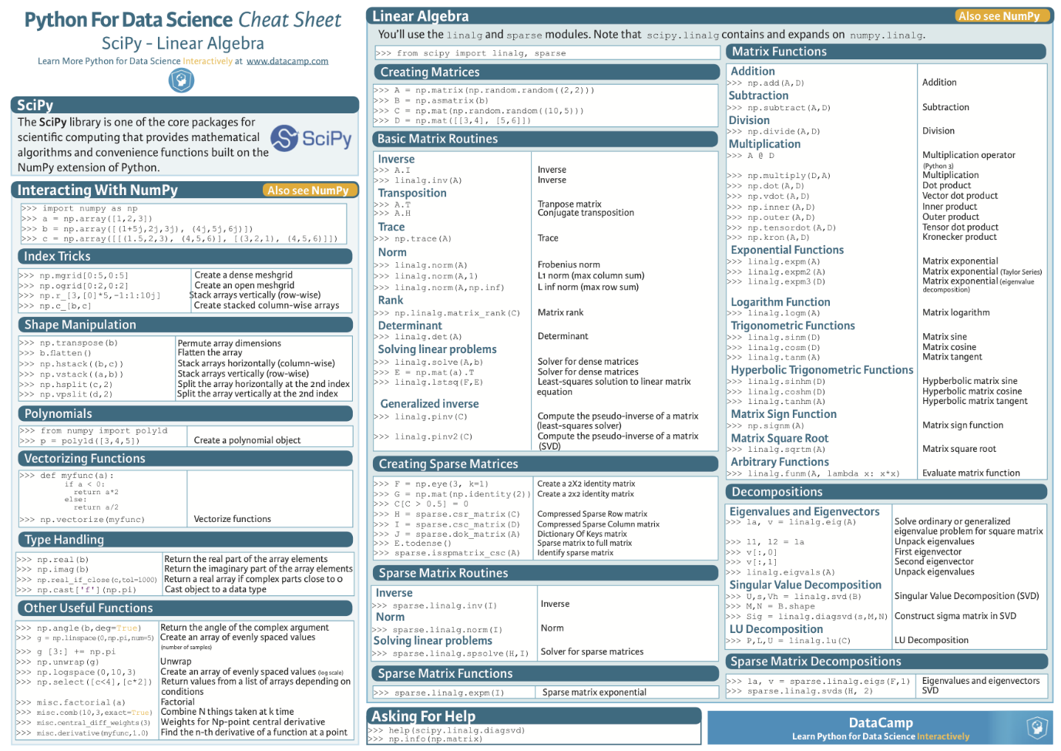

Source — <https://www.datacamp.com/community/blog/python-scipy-cheat-sheet#gs.JDSg3OI>

5. Matplotlib

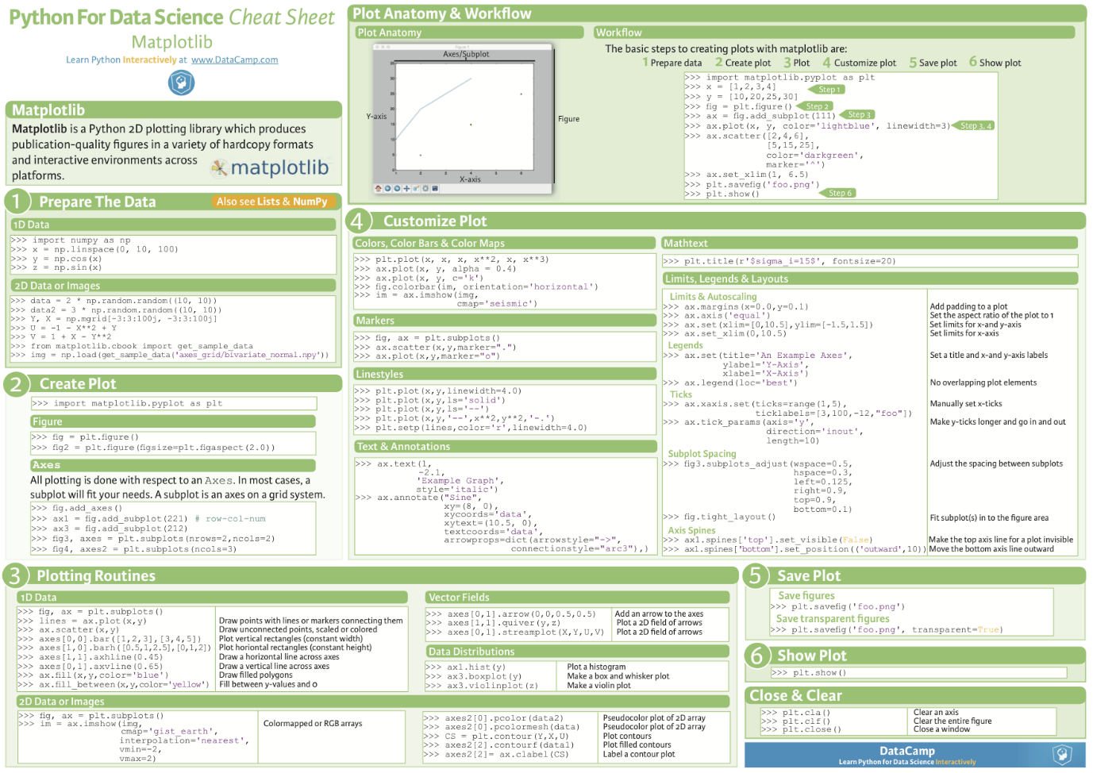

Source — <https://www.datacamp.com/community/blog/python-matplotlib-cheat-sheet#gs.uEKySpY>

6. Scikit-learn

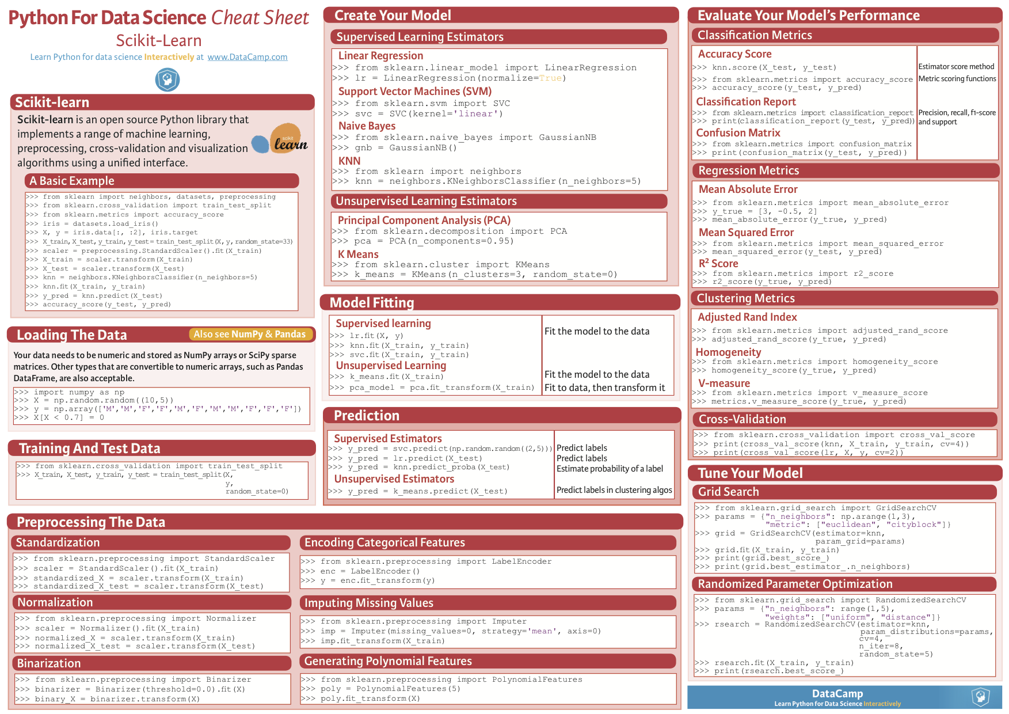

Source — <https://www.datacamp.com/community/blog/scikit-learn-cheat-sheet>

7. Neural Networks Zoo

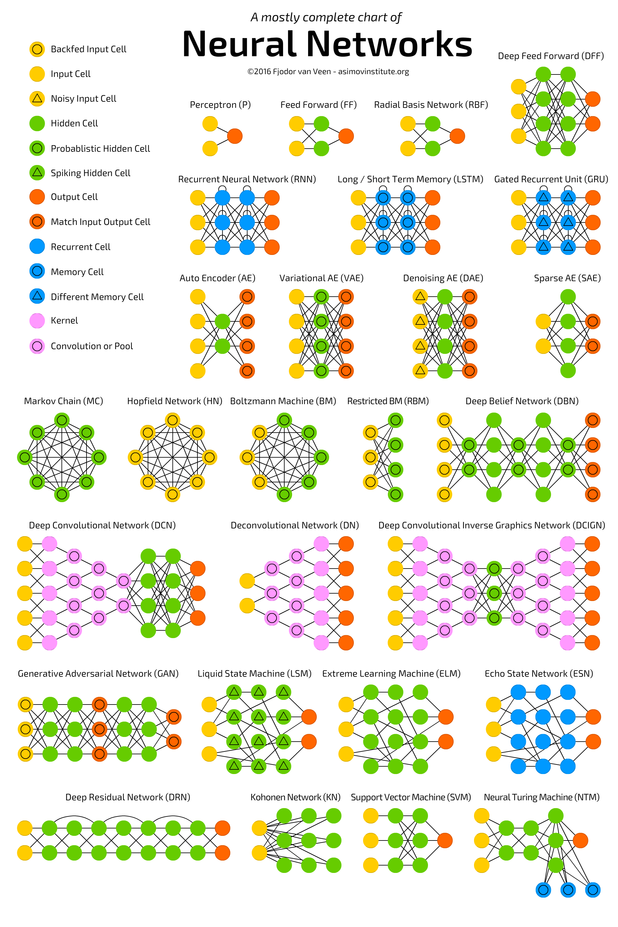

Source — <http://www.asimovinstitute.org/neural-network-zoo/>

8. ggplot2

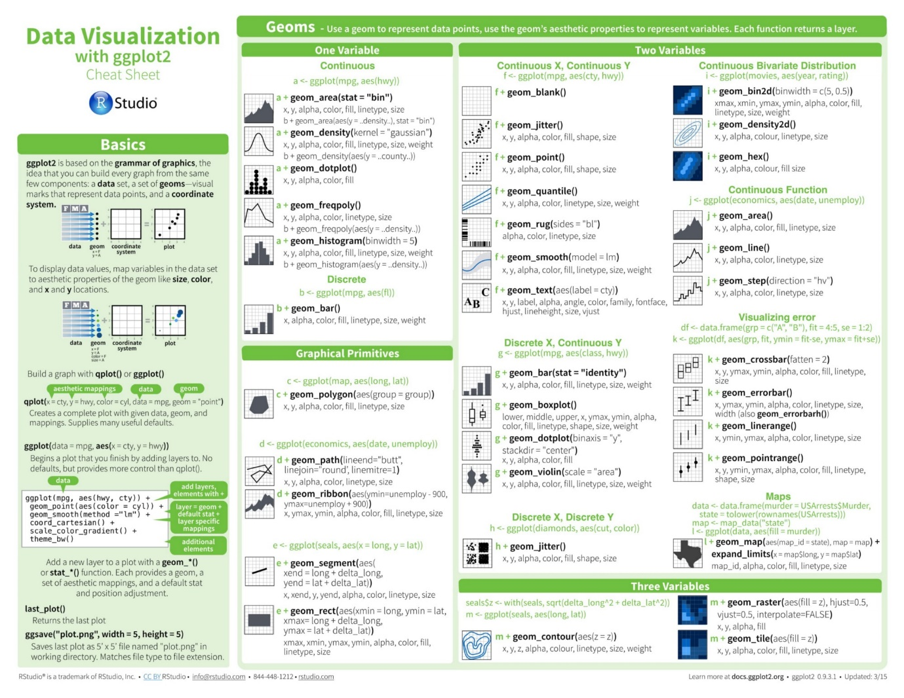

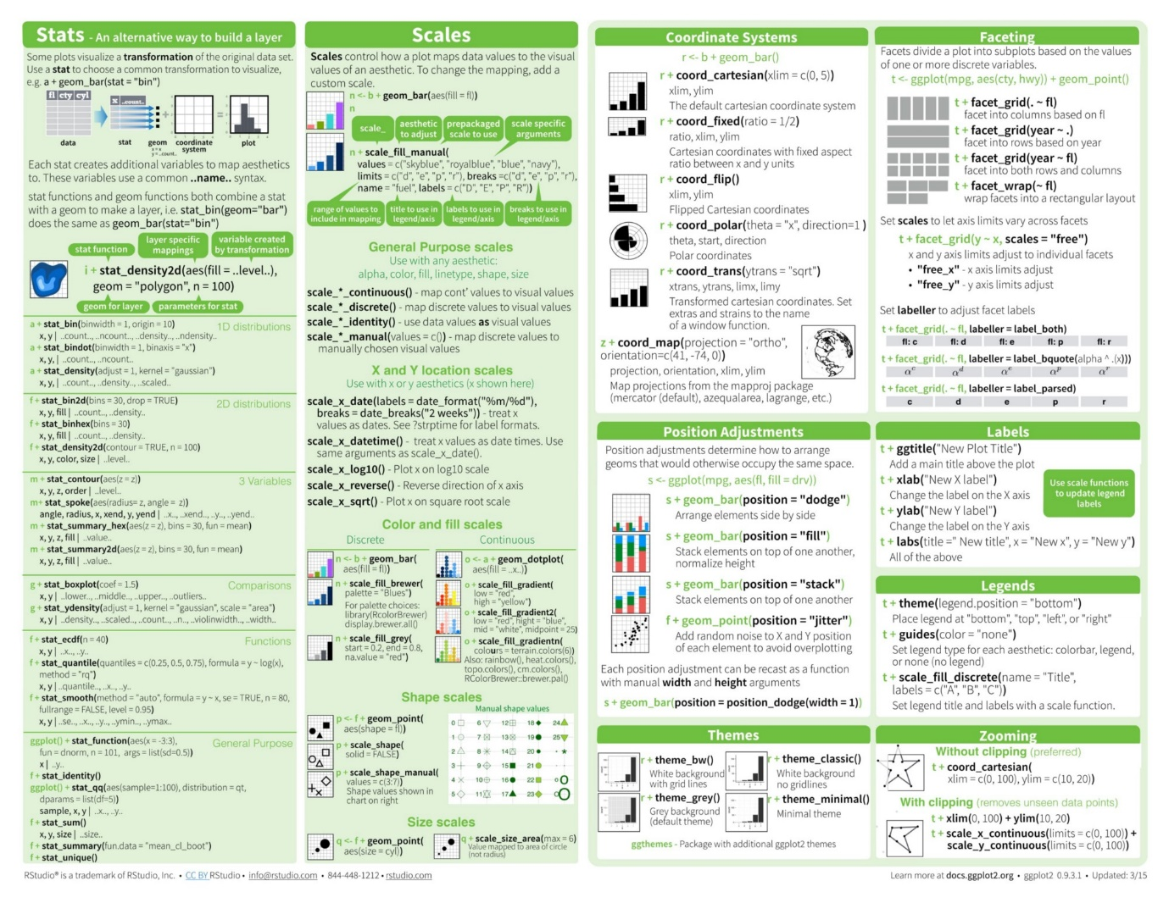

Source — <https://www.rstudio.com/wp-content/uploads/2015/03/ggplot2-cheatsheet.pdf>

9. PySpark

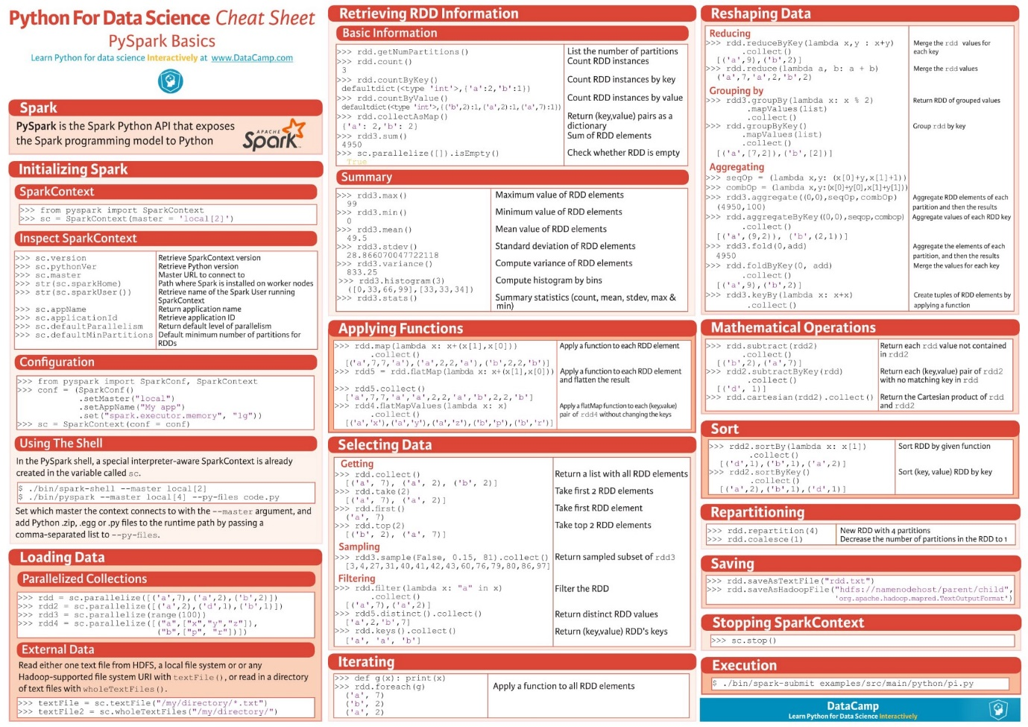

Source — <https://www.datacamp.com/community/blog/pyspark-cheat-sheet-python#gs.L=J1zxQ>

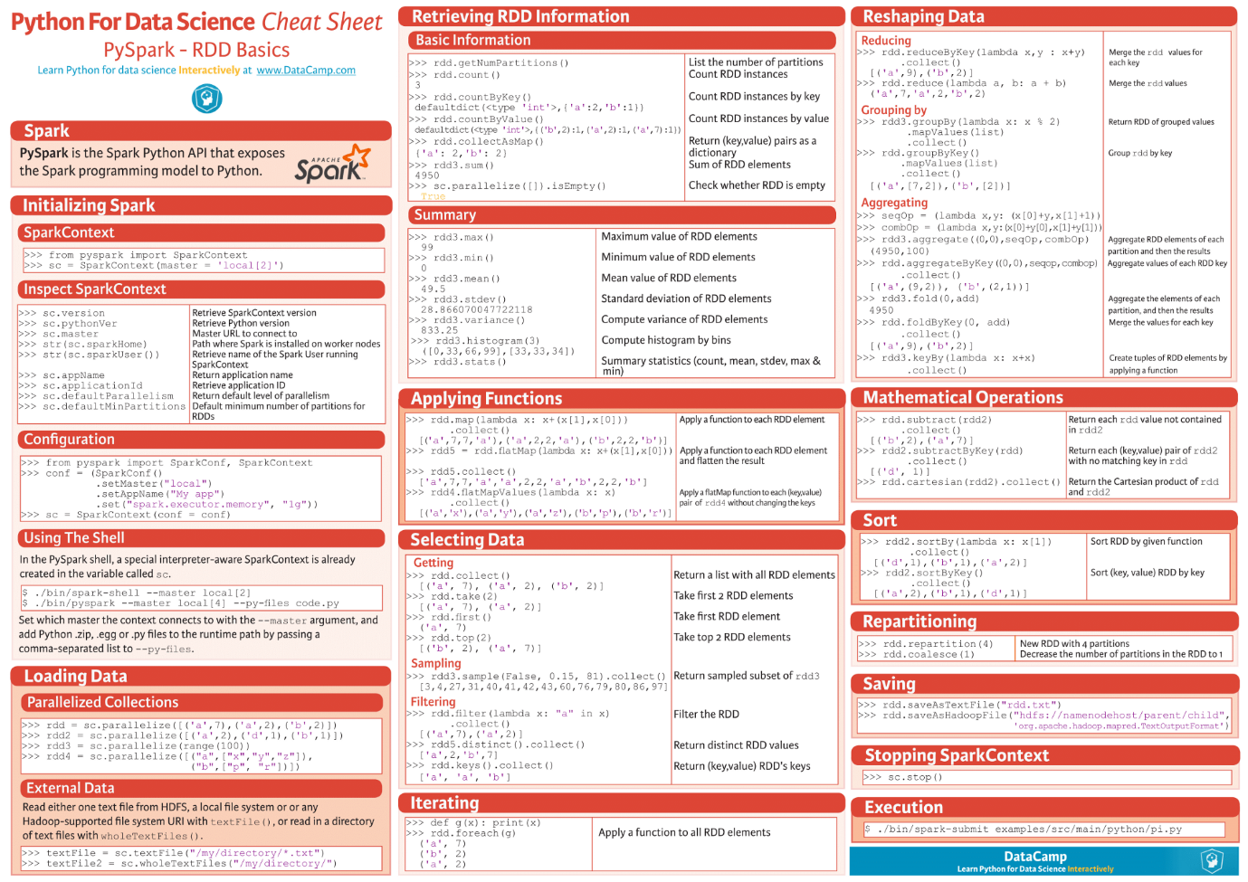

Source — <https://www.datacamp.com/community/blog/pyspark-cheat-sheet-python#gs.L=J1zxQ>

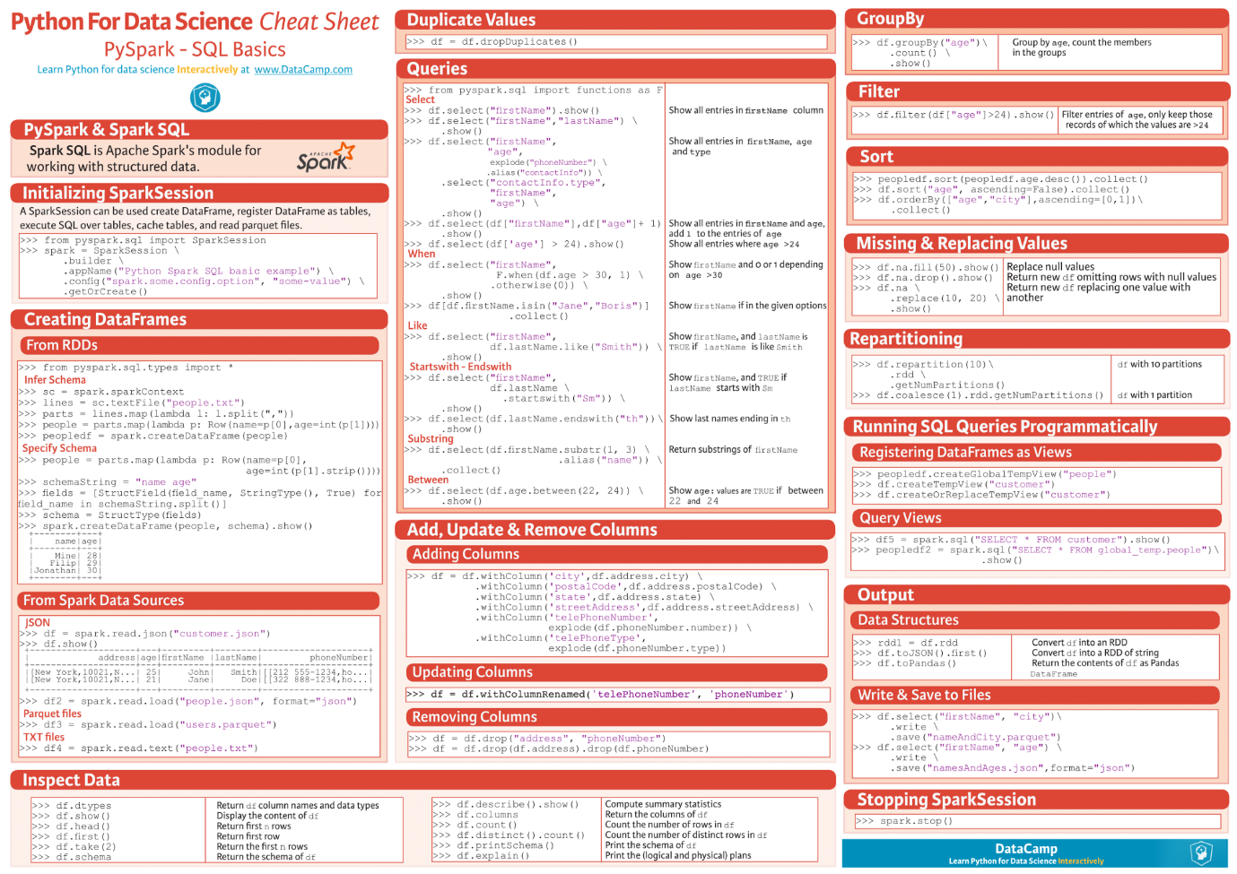

Source — <https://www.datacamp.com/community/blog/pyspark-sql-cheat-sheet>

10. R Studio (dplyr and tidyr)

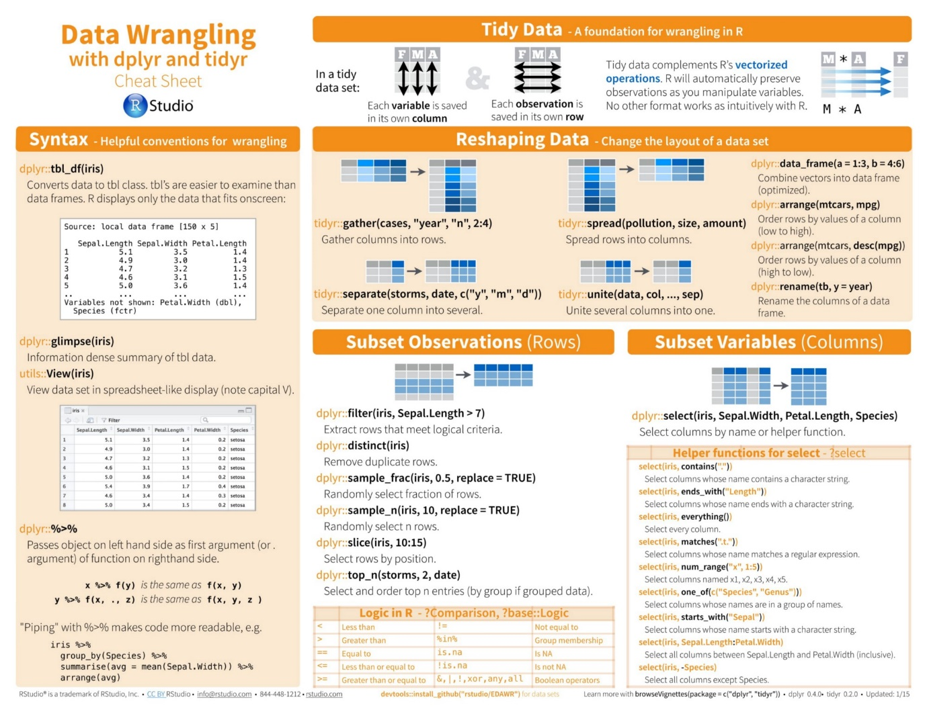

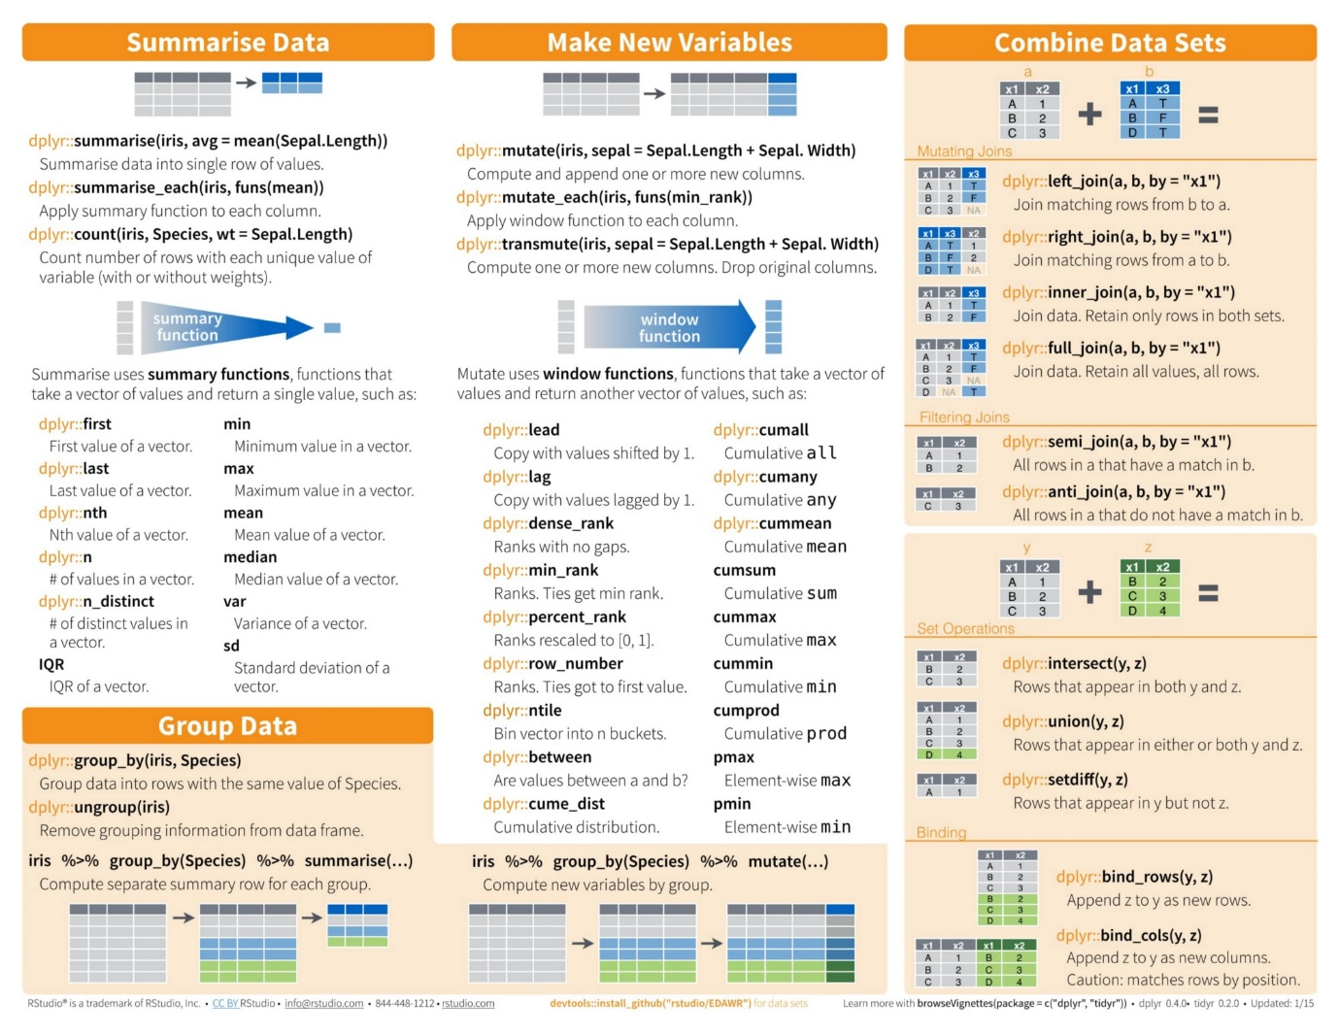

Source — <https://www.rstudio.com/wp-content/uploads/2015/02/data-wrangling-cheatsheet.pdf>

11. Jupyter Notebook

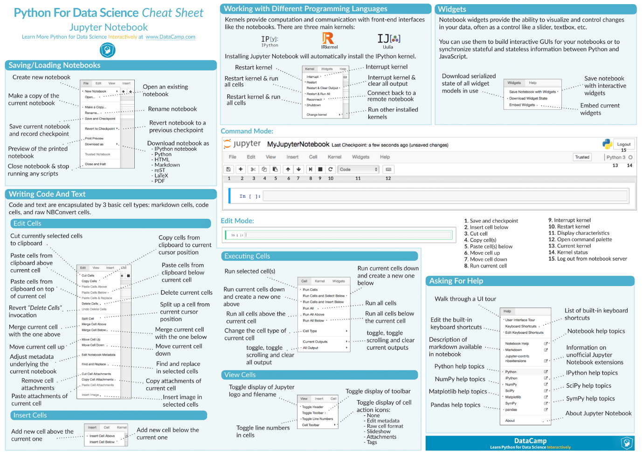

Source — <https://www.datacamp.com/community/blog/jupyter-notebook-cheat-sheet>

**About**

I am a Co-Founder of [MateLabs](http://www.matelabs.in), where we have built [Mateverse](https://www.mateverse.com), a ML Platform which enables everyone to easily build and train Machine Learning Models, without writing a single line of code.

[**Big Announcement: Mateverse is in Public Beta**](https://medium.com/@matelabs_ai/big-announcement-mateverse-is-in-public-beta-a968e727cfdc)

***Tell us about more such awesome cheat sheets on*** [***Twitter***](https://twitter.com/matelabs_ai) ***or learn about more*** [***by email***](https://upscri.be/d91ef9)***.***

* [Machine Learning](https://startupsventurecapital.com/tagged/machine-learning?source=post)
* [Artificial Intelligence](https://startupsventurecapital.com/tagged/artificial-intelligence?source=post)
* [Deep Learning](https://startupsventurecapital.com/tagged/deep-learning?source=post)
* [Technology](https://startupsventurecapital.com/tagged/technology?source=post)
* [Computer Science](https://startupsventurecapital.com/tagged/computer-science?source=post)

• • [](https://startupsventurecapital.com/@kailashahirwar?source=footer_card)

[**Kailash Ahirwar**](https://startupsventurecapital.com/@kailashahirwar)

Co-founder @ Mate Labs | Democratizing Artificial Intelligence

• • [](https://startupsventurecapital.com/?source=footer_card)

[**Startups & Venture Capital**](https://startupsventurecapital.com?source=footer_card)

Top publication dedicated to startups, venture capital, & technology. Want to submit content [editors@redwhale.co](mailto:editors@redwhale.co) A Redwhale Publication→ <https://redwhale.co>

[Related reads](https://towardsdatascience.com/stock-prediction-in-python-b66555171a2?source=placement_card_footer_grid---------0-60)

[Stock Prediction in Python](https://towardsdatascience.com/stock-prediction-in-python-b66555171a2?source=placement_card_footer_grid---------0-60)

[](https://towardsdatascience.com/@williamkoehrsen)

[William Koehrsen](https://towardsdatascience.com/@williamkoehrsen?source=placement_card_footer_grid---------0-60)

[Also tagged Artificial Intelligence](https://hackernoon.com/i-want-to-learn-artificial-intelligence-and-machine-learning-where-can-i-start-7a392a3086ec?source=placement_card_footer_grid---------1-43)

[‘I want to learn Artificial Intelligence and Machine Learning. Where can I start?’](https://hackernoon.com/i-want-to-learn-artificial-intelligence-and-machine-learning-where-can-i-start-7a392a3086ec?source=placement_card_footer_grid---------1-43)

[[](https://hackernoon.com/@mrdbourke)](https://hackernoon.com/@mrdbourke)

[Daniel](https://hackernoon.com/@mrdbourke?source=placement_card_footer_grid---------1-43)

[Related reads](https://medium.mybridge.co/30-amazing-machine-learning-projects-for-the-past-year-v-2018-b853b8621ac7?source=placement_card_footer_grid---------2-60)

[30 Amazing Machine Learning Projects for the Past Year (v.2018)](https://medium.mybridge.co/30-amazing-machine-learning-projects-for-the-past-year-v-2018-b853b8621ac7?source=placement_card_footer_grid---------2-60)

[](https://medium.mybridge.co/@Mybridge)

[Mybridge](https://medium.mybridge.co/@Mybridge?source=placement_card_footer_grid---------2-60)